Summary-This report will discuss the development of the final project of the matter systems with processors and will explain step by step this process, its component, for what purpose was developed, among other things. In summary the project carried out consists of a BOTCAT robot controlled from an application developed for Android devices can also be put into automated mode consisting of a series of movements programmed into the robot. This robot was made in response to the number of accidents at work in construction, also because this small BOTCAT serves to transport sand or building materials in confined spaces. The robot was made with pieces of vex, like servomotors and the structure but it was programmed in an Atmel microprocessor.
HEAVY MACHINERY SCALE AUTOMATION

Daniel Naranjo Imbachi, Fabián Bautista García, Brayan Lozano Polanía
Pontificia Universidad Javeriana

INTRODUCTION
The project carried out by our group consists of a robot of the rover type that consists of a shovel like the one of a retro excavator and a volco to throw things. For its movement consists of four wheels designed in a special way by VEX that allow a greater ease of movement in different directions, the robot is remote controlled mainly from an application programmed in Android language from a virtual platform based on programming blocks called AppInventor2, Platform developed by MIT. The connection between the application and the robot is by means of bluetooth, we use the bluetooth of some mobile device and we connect it to a Bluetooth module HC-05 that connects to the microprocessor Atmel through serial port, hereby we send numbers and characters depending on that you want to do. The robot has 6 servomotors, 4 of which control the wheels and the other two are responsible for the movement of the blade to collect sand or other construction materials, the direction of rotation of the servos is controlled by voltage ranges, in our Case from 1.1 to 2.4 volts rotated in one direction and from 2.7 to 3.3 volts it rotated in the other direction. The robot we made also has a distance sensor that uses the ultrasound to calculate it, which takes into account the speed at which the sound travels and basically consists of a speaker and a microphone, the speaker produces a sound that bounces in the Surface and that the microphone receives the return, this allows the sensor to know that the distance to the objects are very high, the sensor is used to prevent the robot from colliding with objects found Behind it, the algorithm done in Atmel studio for the robot prioritizes the sensor before the movement controlled from the app. Finally for the feeding of the whole assembly two batteries were used, one belongs to vex and is in charge of feeding the circuit and the motors and the other only takes care of the feeding of the microprocessor Atmel.

PROBLEM STATEMENT
Implement in an X-megaB1 card xplained an algorithm that allows the movement of a robot conformed by pieces of the robotics platform VEX robotics. This project arose from the need for safer construction equipment, given that the accident figures in construction are high, we wanted to put ourselves in the task of developing a prototype to scale of what could be the fusion of a retro excavator and a dumper (This for convenience and optimization of resources, since a machine that fulfills the function of two and does it in a more secure way could be much more profitable than doing the two separately). We also did this in order to make a device capable of transporting construction material in confined spaces. Our robot had to have an arm at the end of which had a shovel, also had to have a compartment or dump in which to throw the collected material.

SENSORS

When we start the project we planned to implement two sensors, the MPU6050, HC-SR04 and the Bluetooth module HC-05 but because of the difficulty we had to use the former because they had a i2c communication for data collection could not we implement
Sensor HC-SR04:

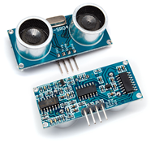

The HC-SR04 is an ultrasonic distance sensor detects objects and calculate the distance that is in a range of 2 to 450 cm. The ultrasonic sensor works and contains all the electronics responsible for making the measurement. Its use is as easy as sending the start pulse and measuring the pulse width of return. Very small, the HC-SR04 is known for its low power consumption, high accuracy and low price for what is replacing polaroid sensors on the latest robots.
With the help of this sensor we make the robot will not crash when moving backwards, we get at a distance of 27cm receives a signal that makes the robot is directed to the opposite direction, ie forward.
The sensor has 4 pins, which are:
- VCC
- Trig (Shooting ultrasound)
- Echo (reception ultrasound)
- GND
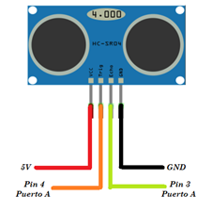
Function used to read the sensor HC-SR04

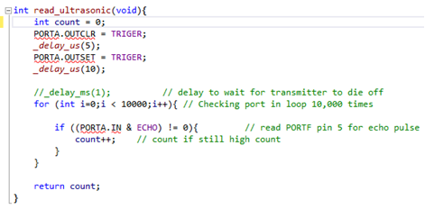
In this portion of code used when the sensor to go back and the sensor detects a distance of 27cm, the feed carriage for a second, which does not allow it crashes.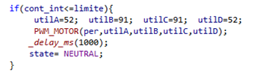
HC-05 Bluetooth module:
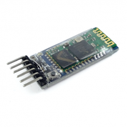
This is one of the most important sensors in our project because through it we will control our car with the help of an Android application which we will discuss later.
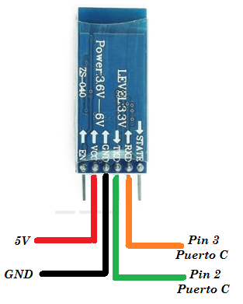
The Bluetooth Module HC-05 uses the UART protocol RS 232 serial. It is ideal for wireless applications, easy to implement PC, microcontroller.
will discuss later.
The Bluetooth Module HC-05 uses the UART protocol RS 232 serial. It is ideal for wireless applications, easy to implement PC, microcontroller
The card includes an adapter with 6-pin easily accessible for use in breadboard.
The pins of the corresponding board are:
- IN
- VCC
- GND
- TX
- RX
- STATE
To use this sensor we use UART serial communication we implemented through library developed in class.
The HC-05 module is configured default as follows:
- Mode or role: Slave
- Name by defecate: HC-05
- default pairing code: 1234
- The default speed (baud rate): 9600

HC-05 module has 4 states which is important to know:
Offline status:
- In this state as soon feed module, and when not established a Bluetooth connection with another device
- LED module in this state flashes quickly
- In this state unlike the HC-06, HC-05 can not interpret the commands AT
Connected state or communication:
- enters this state when a connection with another Bluetooth device is established.
- The LED does a double flash.
- All data entering the HC-05 by the pin RX are transmitted by Bluetooth to the connected device, and data received are returned by the pin TX. Communication is transparent
AT 1 mode:
- To enter this state after connecting and powering the module requires pressing button HC-05.
- In this state, we can send AT commands, but at the same speed with which it is configurado.- THE LED module flashes rapidly in this state as in the disconnected state.
AT 2 mode:
- To enter this state you need to press the button when powering the module, ie the module must be turned on with the button, after turning can be released and remain in this state.
- In this state, to send AT commands is necessary to do so to 38400 baud, this is very useful when we forget the speed with which we left our module configured.
- LED module blinks slowly in this state.

This bluetooth module can be used as a slave or master, but in our particular case we decided to use it as a slave, since we were going to be controlled through a mobile phone or Bluetooth device which was the one who acted as master.

Components:
In the project, we use 6 engines VEX and 4 drivers that we worked as a bridge H, used for the construction of VEX parts, and overturned made of acrylic prototype.
L293D Integrated circuit:
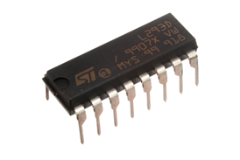

We use this integrated to control movement by the arm handles the blade. We saw the need for this integrated as this serves as a bridge H (a circuit arrangement of transistors and diodes which allows us to control the polarity of two terminals output depending on a logic inputs), ie it allows us to control the direction of current flowing through the motor, which causes a motor to rotate to one direction or the other.
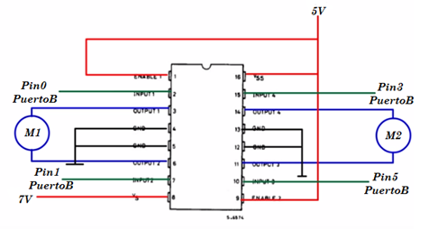

Image can be seen connections made microcontroller pins, whereby the motor control is performed, which was carried out by two states, which we call PALA UP and DOWN.
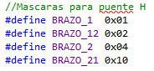
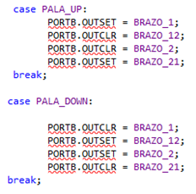

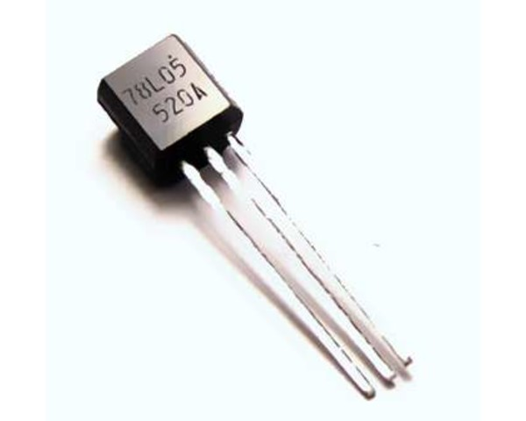
78L05 voltage regulator:
"A voltage regulator as an electronic device that feeds a given amount of stress and is capable of delivering a lesser amount and conditioned for a particular computer." The need for this component was as feed all our circuit with a 7 volts battery, since the motors and sensors operating with 5 volts.
.
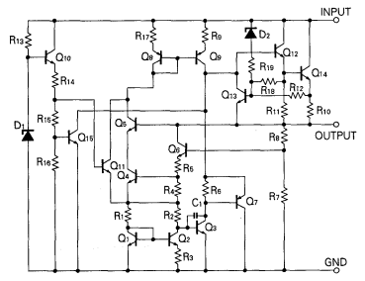
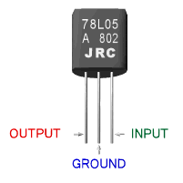

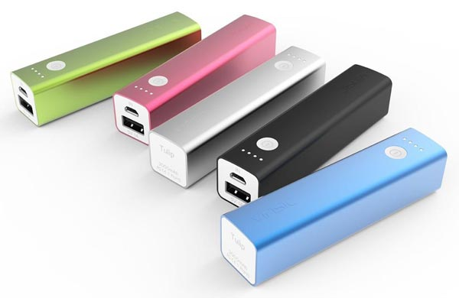
PowerBank:
Because of the battery 7 volts we use to supply the motors and sensors, could power the microcontroller xmega128B1, but when sending data via Bluetooth did not provide enough energy, we saw the need to feed our microcontroller with a power bank which gave us the 5 volts with which it can operate our microcontroller.

OUTPUT PERIPHERALS.
PWM
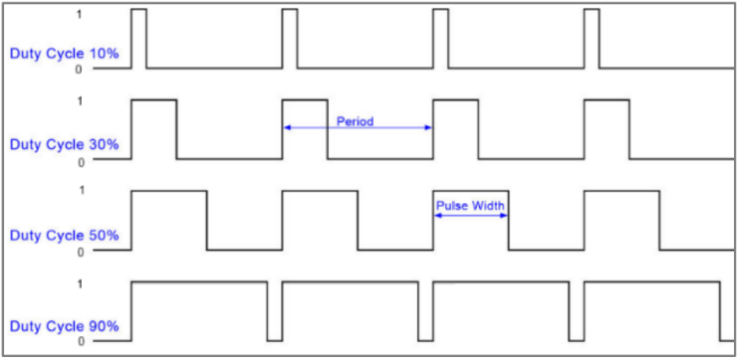
Pulse-width modulation.
Pulse-width modulation (PWM), or pulse-duration modulation (PDM), is a modulation technique used to encode a message into a pulsing signal. Although this modulation technique can be used to encode information for transmission, its main use is to allow the control of the power supplied to electrical devices, especially to inertial loads such as motors.
The average value of voltage (and current) fed to the load is controlled by turning the switch between supply and load on and off at a fast rate. The longer the switch is on compared to the off periods, the higher the total power supplied to the load.
The term duty cycle describes the proportion of 'on' time to the regular interval or 'period' of time; a low duty cycle corresponds to low power, because the power is off for most of the time. Duty cycle is expressed in percent, 100% being fully on.

A vex controller is used to operate the motors, to operate the engines of the Vex Robotics platform you need to use PWM, with ranges of voltages it is possible to control the direction of a Vex engine. The ranges are:
1.1 volts at 2.4 turn right.
2.7 volts to 3.3 turn left.
Motor Controller Module
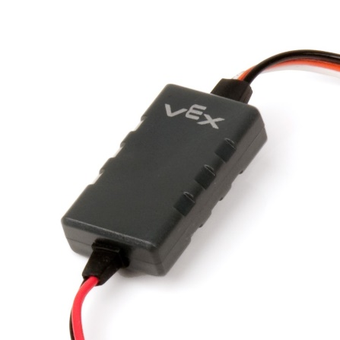
Motor Controller 29.
The Motor Controller 29 regulates the speed of a VEX motor based on a signal it receives from a VEX Microcontroller. This allows for control of any VEX motor that doesn’t have a building motor controller, such as the VEX 2-wire motors.

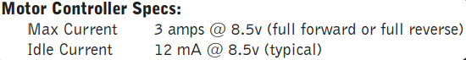
Motor Controller Specs.

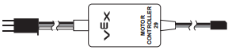
Vex Controller .

2-Wire Motor 393
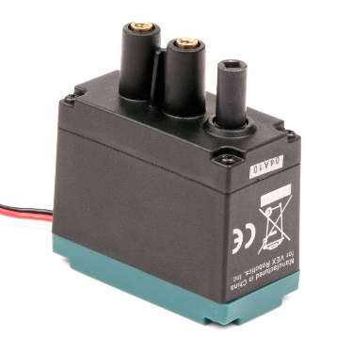
2-Wire Motor 393.
The 2-Wire Motor 393 is the primary actuator used in the VEX Robotics Design System. Build rotational mechanisms using this motor. Drive bases, rotational joints, conveyor belts, or anything that spins can be built using the 2-Wire Motor 393.
Motor Specifications :
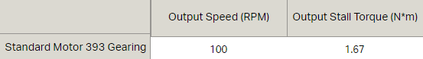

- Each VEX Motor Controller Module can drive one 2-wire motor.
- Max motor stall current: 3 amps.
- Max battery voltage: 8.5v (with fully charged 7.2v battery).
- Connect 2-wire socket to motor 2-wire plug.
- Easy reverse, swap connection to motor plug.

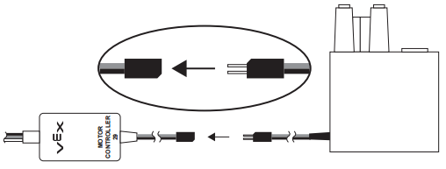
Connect 2-wire motor plug to motor controller 2-wire Jack.

Mecanum wheels
Mecanum wheels allow savvy robot designers to create drivetrains capable of moving in any direction using a standard chassis shape. Simply power each wheel with a different motor and change the directions the wheels spin to get your robot to move in different directions.

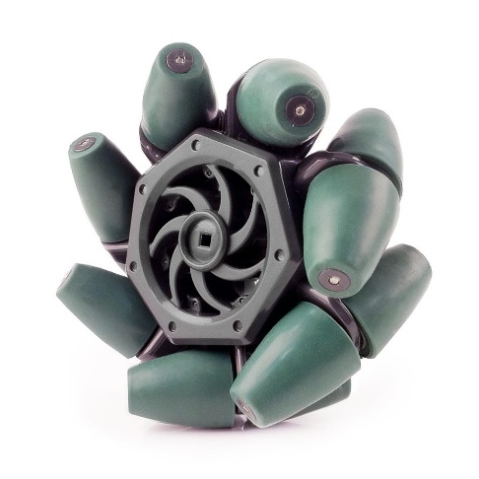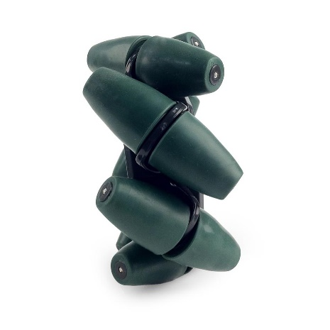
Mecanum wheels.
Each roller is tailored for the individual wheel diameter, and provides the correct, constant radius. We don't share rollers between wheel types -- these wheels aren't "almost round" -- they're actually round! This smooth-ride provides higher efficiency and reduces wasted power. This is especially important in mecanum drivetrains to provide smooth holonomic motion without high motor current draw.
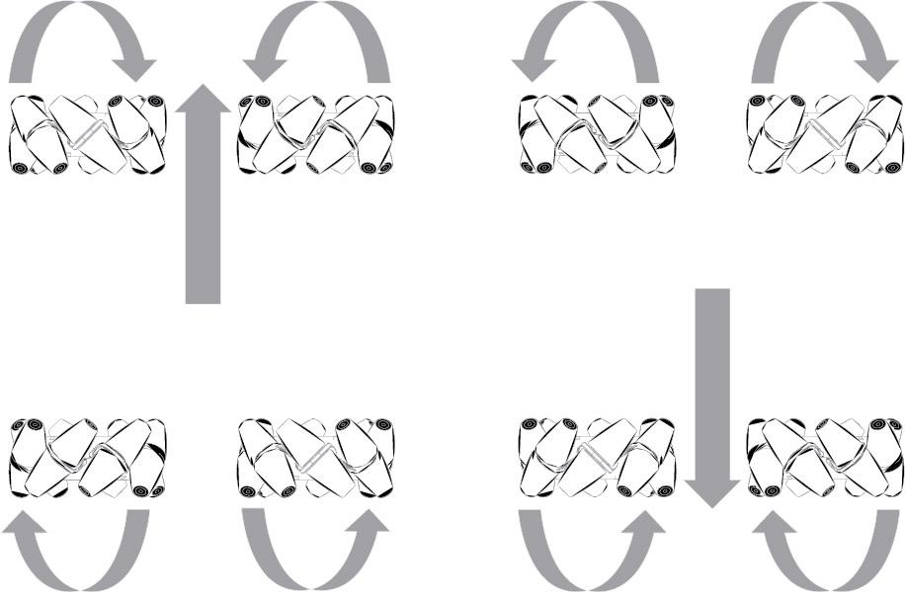
Movement of the base.

FINITE STATE MACHINE.

For the state machine there are three general states, one where it reads bluetooth, asks for the flag "USART_RXCIF_bm", which is a status of the peripheral uart, and the end that drives the selected engines in the right directions to meet the order .
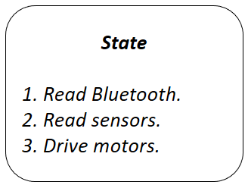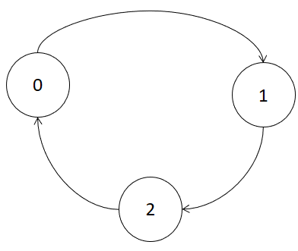
FSM.

APP
To handle robot, we implemented a mobile app for android phones, this app was designed in "App Inventor 2", the programming is in blocks, the appearance of the app ends is the following:

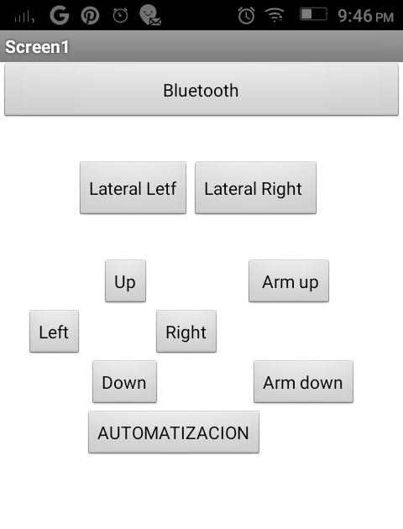
App completed.

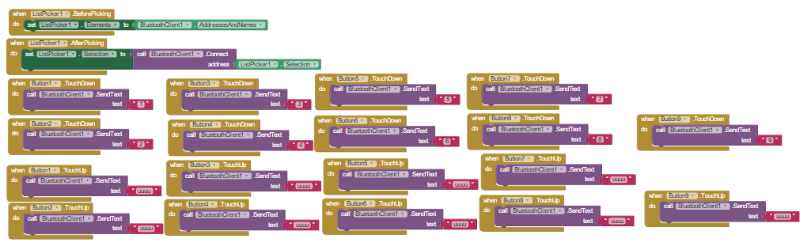
Block programming.

First the connection is made where a button called "Bluetooth" is generated; this button allows pairing the module and the telephone.
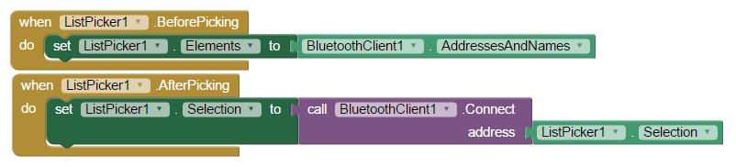
Then the operation is based on sending a character when the button is pressed and send another one when the button is released.
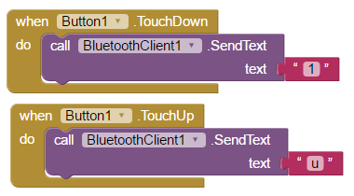

CONTRIBUTIONS AND PROBLEMS
The main problems were that the battery could not fully supply what the card required and caused too much current through the controller and burned it, in addition to turning off the bluetooth every time. We also had some problems with the operation of the ultrasound sensor in terms of understanding how to read and receive data.

CONCLUTIONS

In conclusion we can say that in the course of this project we learned to make use of the datasheet of the various sensors and the Atmel card as some things was a challenge but with the help of these important sources we were able to understand and work until reaching the desired goal.

REFERENCES

Search on the internet:

1) L293D Integrated circuit:
http://www.electrontools.com/Home/WP/2016/03/09/como-funciona-el-puente-h-l293b/

2) HC-05 Bluetooth module:
http://www.naylampmechatronics.com/blog/24_configuracion-del-modulo-bluetooth-hc-05-usa.html

3) Sensor HC-SR04:
https://electronilab.co/tienda/sensor-de-distancia-de-ultrasonido-hc-sr04/

4) Power Bank:
http://www.ibertronica.es/blog/productos/power-bank/

5) Google Traductor:
https://translate.google.com/?hl=es

 

